AFM Visualizer

*Ver. 1.0.0*

User Manual

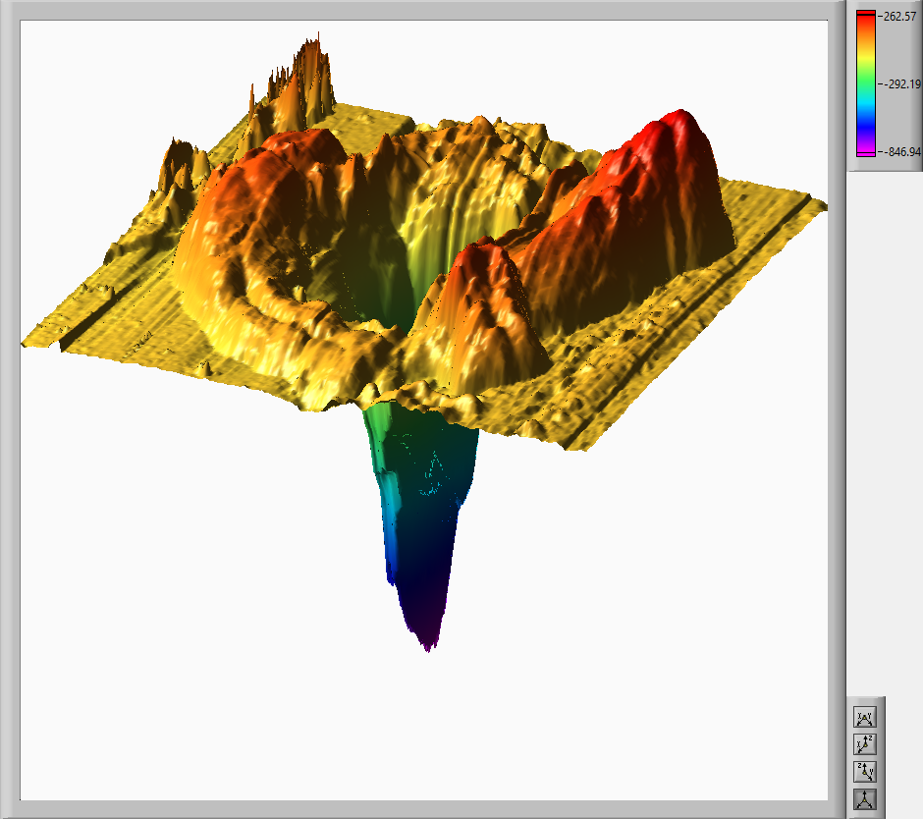

**Copyright**

**Copyright © 2016**

Fabrizio Donnarumma and Kermit K. Murray

This program is free software: you can redistribute it and/or modify it under the terms of the GNU General Public License as published by the Free Software Foundation, either version 3 of the License, or (at your option) any later version.

This program is distributed in the hope that it will be useful, but WITHOUT ANY WARRANTY; without even the implied warranty of MERCHANTABILITY or FITNESS FOR A PARTICULAR PURPOSE. See the GNU General Public License for more details.

You should have received a copy of the GNU General Public License along with this program. If not, see <http://www.gnu.org/licenses>.

Fabrizio Donnarumma and Kermit K. Murray

Murray Group   
Louisiana State University, Department of Chemistry   
Choppin Hall, Baton Rouge, LA-70803

Phone: +1 225 578 3008   
Email: [fabrizio@lsu.edu](mailto:fabrizio@lsu.edu)   
Web: <http://mass-spec.lsu.edu>

Contents

1. Description of the software 1

1.1 Key Features 1

2. Installation 2

2.1. System requirements 2

2.2. Installing AFM Visualizer 2

3. Using the software 3

3.1. Supported Files 3

3.2. Loading a file 3

3.3. Controlling the plot area 4

3.4. Positioning the Start and End cursor 5

3.5. Processing an image 5

3.6. Volume calculations 6

3.7. Additional controls 6

3.7.1. Processed Cursor 6

3.7.2. Rescale Z Axis 7

3.7.3. Correct proportions 7

3.8. Exporting processed images 8

# 1. Description of the software

AFM Visualizer 1.0.0 is a LabVIEW based program designed to display three dimensional representation of atomic force microscope topography dataset.

## 1.1 Key Features

* Accept any tab delimited files (.cvs, .txt etc…)
* Zoom on an area of interest
* Calculation of volumes with a double filtering option
* Information about the dataset (number of data points, min& max height )
* Control on the color scale
* Export of processed images in TIFF, PNG, JPEG, BMP, EPS and EMF formats.

# 2. Installation

## 2.1. System requirements

AFM Visualizer is developed using National Instrument LabVIEW (LV) and it requires LabVIEW 2016 runtime engine, NI Vision Common Resources 2016 and NI Vision Runtime 2016, which can all be obtained from NI. The windows installer already includes the runtime needed for Windows 10/8.1/7 (SP1) 32-bit/7 (SP1) 64-bit/Server 2012 R2 64-bit/Server 2008 R2 64-bit.

The installer is available only in 32-bit version. The standalone is compiled using a 32-bit LV version. A 64-bit version can be compiled opening the source files with a LV 64-bit.

MAC OS user should be able to use the software starting from the source files. Please visit www.ni.com for more info on how to run LabVIEW on a MAC OS system.

Adobe Reader or a compatible web browser must be installed in order to open the User Guide.

## 2.2. Installing AFM Visualizer

To install AFM Visualizer with the Win32 installer:

1. Unzip the downloaded file into a temporary folder.
2. Double click on the setup.exe file.
3. Follow the instruction on screen.

To install the AFM Visualizer with the standalone executable:

1. Unzip the downloaded file into a folder of choice.
2. Double click AFM Visualizer.exe

# 3. Using the software

## 3.1. Supported Files

The software utilizes LV “Read Delimited Spreadsheet.vi”, which interprets any ASCII file organized as a spreadsheet (e.g. a cvs file). The space delimiter is a keyboard tab. Please modify the space delimiter character of your raw files if different. This can be easily accomplished using a text editor such as Notepad++ and replace functions.   
You can find a raw file example in the folder “examples” inside the installation directory.

It is assumed that the unit of each value is nanometer. If this is not the case, please convert the raw file before loading it.

## 3.2. Loading a file

To load a raw file, you can press the icon 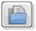 on the top left corner of the window. As soon as you select a file, the left plot area will be populated with a top view of your surface. Loading unsupported files will result in an empty plot. The left panel of figure 1 shows the result of loading the example file provided with the software. The icons on the bottom right corner of each plot area allow to switch the view.

C:\Users\Fabrizio\AppData\Local\Microsoft\Windows\INetCache\Content.Word\totat.tiff  
Figure 1: view mode for the plot area. On the left, a top view (Z-axis view). On the right, a front view (Y-axis view).

C:\Users\Fabrizio\AppData\Local\Microsoft\Windows\INetCache\Content.Word\totat.tiff  
Figure 2: view mode for the plot area. On the left, a side view (X-axis view). On the right, an arbitrary orientation view (arbitrary view).

Opening a new file will overwrite the previous one. The software supports loading of only one file at time.

## 3.3. Controlling the plot area

The plot area are displayed using the LV 3D Surface Plot control. Clicking on a plot area with the right button of your mouse will display a 3 choice menus. The option “3D Plot Properties” will open the window in Figure 3.

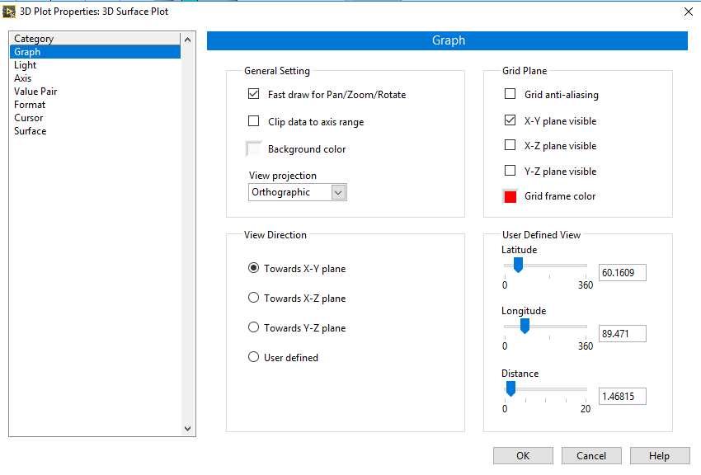  
Figure 3: 3D Plot Properties. These properties allow for further customization of the plot area

The help button will further navigate you through all the possible customization options. For further details, please visit the National Instrument page for this controller at the following address: http://zone.ni.com/reference/en-XX/help/371361J-01/lvpage/plotpropertydb

## 3.4. Positioning the Start and End cursor

In order to select an area of interest, you need to position the two cursors in the left plot area. You can move a cursor by dragging it on the desired location with your mouse. To move it precisely to a location, you can use the controls to the right of the plot area. First, select which cursor you want to move. Then, use the 4 arrows to move it 1 pixel at time. The two small windows provide details on the position of each cursor. The guidelines may disappear below the surface because they are at the same height as the cursor itself but may cross area where the surface is higher. If you need to see them, simply move the cursor back and forth with the arrows. This will put the cursor 10 nm higher than the highest point of the surface.

## 3.5. Processing an image

Once the cursors are in the desired position, you need to specify the pixel diameter. This is the step size used during the AFM topography acquisition and determine the space between each data point. A wrong pixel diameter will result in wrong distance and volume calculations. Hitting the process button will populate the left plot area (processed plot). Figure 4 shows the result of processing the example dataset included in the installation.

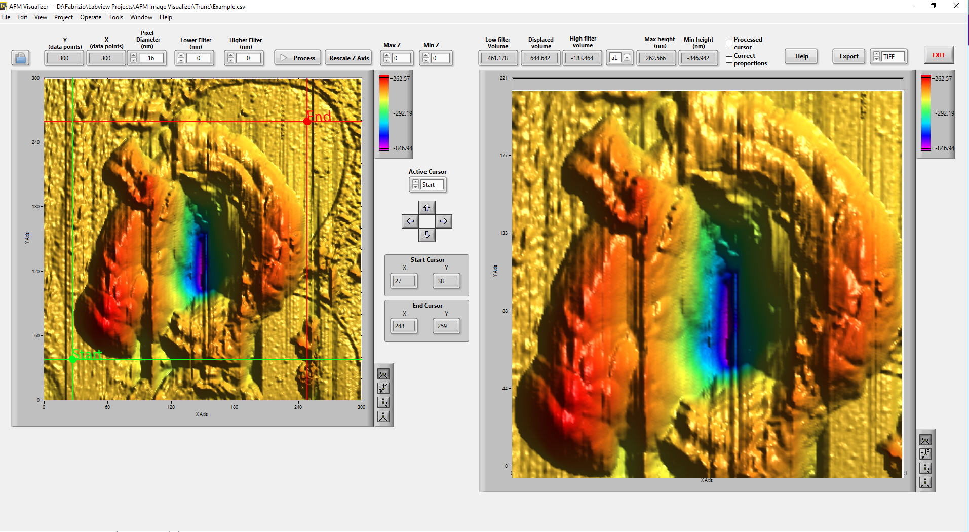  
Figure 4: example of processed AFM image

## 3.6. Volume calculations

AFM Visualizer calculate volumes using the pixel size and approximating each pixel to a rectangular box with height equal to the Z value of the pixel. It is possible to specify a lower and a higher filters. This allow to determine an area, which may be considered the average height of the sample (or baseline). For instance, the example dataset shown in Figure 4 was processed with both filters set to 0. If we process an area of the surface which represent a “baseline” region, we can use the values of the max and min height (just above the processed plot) as higher and lower filters. The difference between the two volumes is automatically displayed in the “Volume difference” field. Three different display unit (femtoliter, attoliter and zeptoliter) are available.

## 3.7. Additional controls

### 3.7.1. Processed Cursor

This option will display a cursor with coordinate into the processed plot area. The cursor can be moved with the mouse. Figure 5 shows an example of the cursor after activation of the option.

### 3.7.2. Rescale Z Axis

This control allows to quickly modify the Z axis in front and lateral view mode. Figure 5 shows an example of rescaling using this control. To reset the zoom, press again the “process” button.

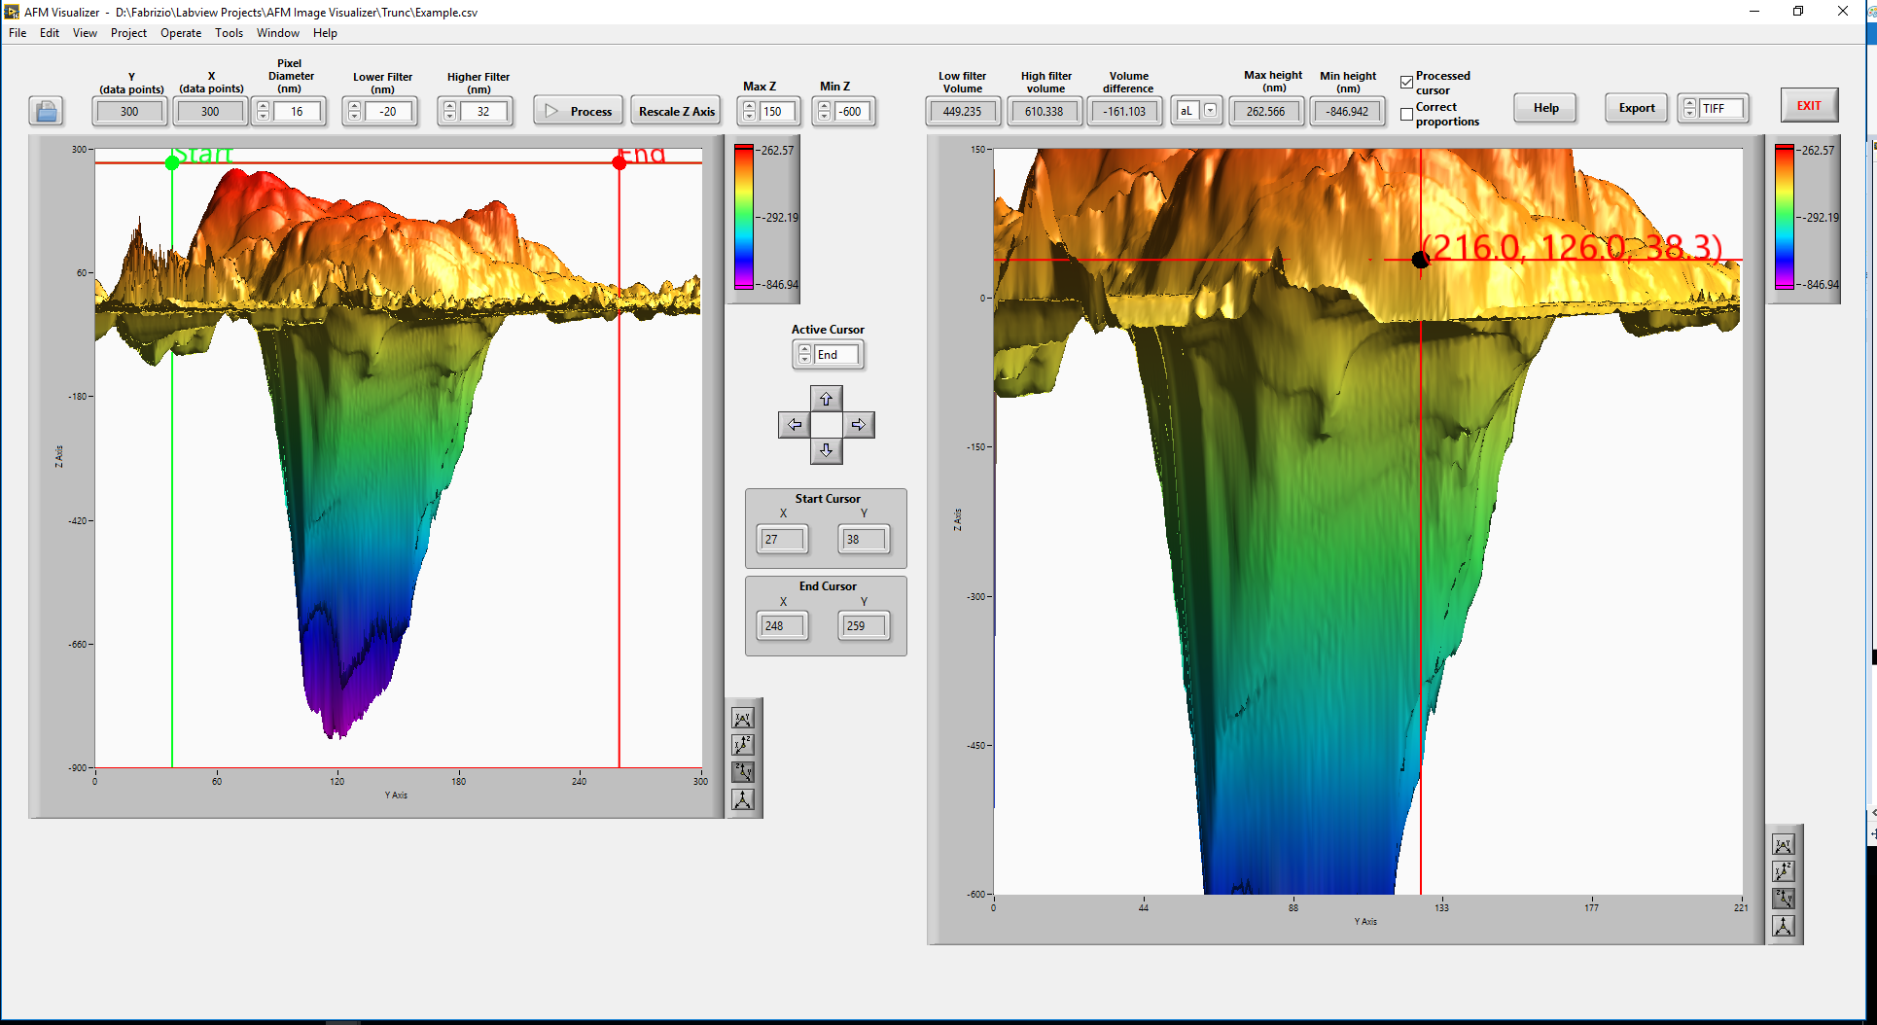  
Figure 5: example of additional controls. The processed plot area has been rescaled along the Z axis and displays a guiding cursor.

### 3.7.3. Correct proportions

This function allows to correct the Z axis values to match the same scale of the X and Y axis. Figure 6 display an example of this rescaling option.

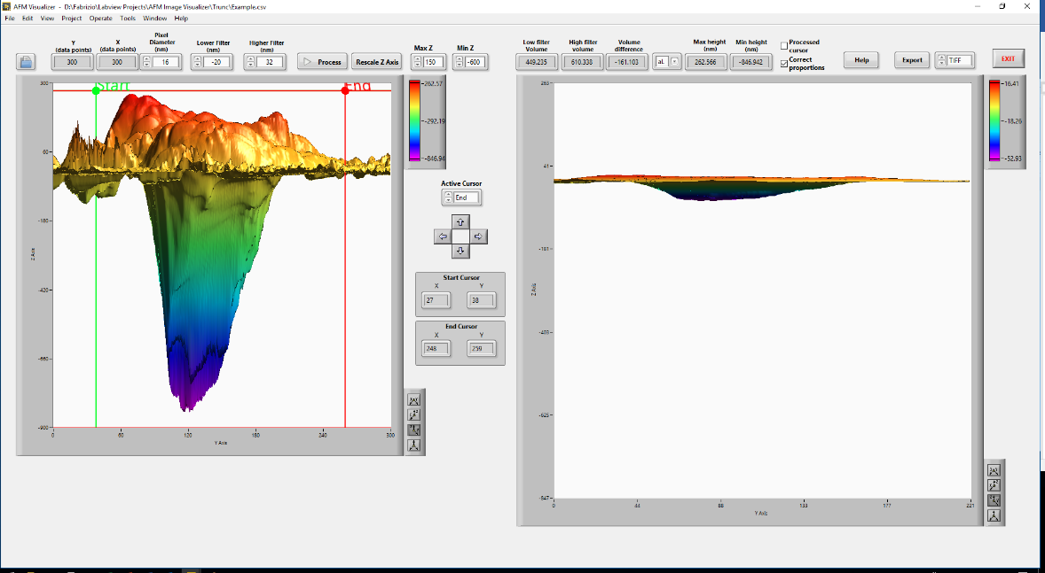

Figure 6: example of rescaling by correcting the proportions of the Z axis.

## 3.8. Exporting processed images

AFM Visualizer support exporting to the following formats: TIFF, JPEG, PNG, BMP, EMF and EPS. EMF and EPS do not retain the axis and the scale while the other export a perfect replica of the processed image. Figure 7 shows an example of exported images.

D:\Fabrizio\Labview Projects\AFM Image Visualizer\Trunc\Example.EMF   
Figure 7: example of EMF (left) and PNG( right) images.

